Tis the season! This month in RE we will be very busy with Holiday activities. Here’s the schedule:

- Sunday Nov 27th Childcare provided, no RE programming.
- Sunday Dec 4th Regular Programming – Pageant prep & Practice
- Sunday Dec 11th Regular Programming – Pageant prep & Practice.
Holiday Workshop for the kids during coffee hour.
- Sunday Dec 18th FPC Multigenerational Pageant followed by Hanukah
party with our friends from Shirat Hayam.
- Saturday Dec 24th Christmas Eve Service. 4pm Start
- Sunday Dec 25th Christmas Day! There will be no childcare or RE programming.

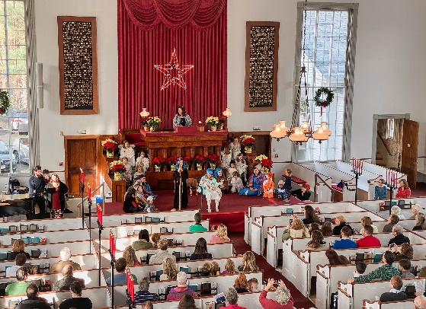
This year we will be back to an in-person Pageant with all our beloved traditions. We’ll have Angel, and Maccabee boys, Santa Lucia dancers and lots of woodland creatures. Of course, we’ll have Mary and Joseph and our own Baby Hazel as Jesus in her first big theatrical performance! We’ll have familiar pageant songs, beautiful bells, the shining star above the altar and a holiday sing-along. And for the first time we’ll have adults in the pageant to reflect our multigenerational community. Our pageant will be followed by a wonderful celebration of Hanukkah with our friends from Shirat Hayam during coffee hour.

Our Christmas Eve service has an earlier start this year. Edwin’s traditional 30 minute musical prelude will begin at 4pm, with the service staring at 4:30 pm., in an effort to make the service more family friendly. This year the RE team is offering childcare for parents who would like to enjoy the music before the service starts.

"Christmas magic is silent. You don't hear it–you feel it. You know it. You believe it." – Kevin Alan Milne
Love & Blessings, Kate

