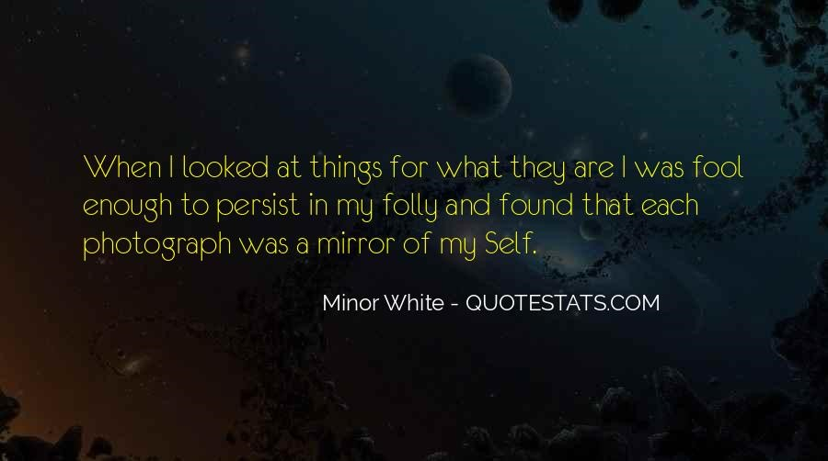
Dear Sacred Seeing participants,
I am so excited to invite you to our Sacred Seeing workshop which will focus on photography as a contemplative practice this Fall.! My goal is not to teach you technical aspects of photography (although I am happy to help if you’d like), but to introduce you to a way to use the creation of images to learn about yourself, your place in the world and to create meaning for yourself going forward. This course will take the focus away from product and put it squarely on process; in this class images are reflections of an inner process, a window into who you are. For the next 5 weeks, we will explore a deeper understanding of images as worshipful reflection by being open to “receive” images, by experiencing with them at others, and by seeing them for what they are, and what else they are.
The basic structure of the class:
- Chalice lighting & brief check in: Gathering our thoughts, being present. Brief discussion of work you’ve done the week before. This will be a time to talk in the group about your reactions and self-discoveries, always within your comfort zone (you can always pass.)
- Eyes of the Heart: We will be viewing our images together as a group each week. This will be our opportunity for the image-creator to think more deeply about their work and experience it’s meaning as seen through other’s eyes. We will NOT be critiquing the images and there will be NO evaluation of the work – there will only be our discussion of experiencing the work. No one wins for the most beautiful image, the most artfully composed image, or the “framable” photo with dazzling colors. We’re going for insight, paying attention to what we’re drawn to, what images remind us of, how they make us feel.
- What’s next? Each week I will introducing a new topic/assignment with plenty of examples designed to illustrate the concepts we’ll be exploring in the homework, which you complete during the next week. You will email me 2 images that move you in some way – maybe you love it, maybe you have no clue why you are drawn to it, maybe there is something that you really don’t like about it but you keep going back to it. Be open to the images that speak to you in some way.
- Closing Words: A re-centering of our sacred space to close our work together for the day.
What you need to participate:
- Camera of any kind! (and yes - a phone is absolutely fine as is a DLSR is also fine)
- A means of emailing images to me once a week.
- Pre-class homework assignment (outlined below)
- Your open heart, your willingness to explore and experiment, and your readiness to look at images with the “eyes of the heart”.
Your first assignment happens before our first gathering.
We will begin on Sunday morning by getting to know one another through your first assignment. We would love for you to email Kate 3 photographs that you have created that relate to how you’ve experienced these last 18 months – something about your “covid life” that you would like to share. You DO NOT have to “like” them or think they are beautiful, well composed or appealing to others (in fact, they might leave you unsettled yourself.) We are looking for a few photos that really resonate with YOU, even though you might not really know why! Who you are and how you see will be present in every image you create! As with all assignments, you will be encouraged to share with the group, but only as you are comfortable.
There is something about viewing one’s own work in the context of other people that allows us to see ourselves and others in a new way. Our hope is that you will feel moved by this creative process in a small and close community and will gain much insight into your own spiritual life.
Please email 3 photos to Kate at: sullivankate@comcast.net by MONDAY JULY 5th.

