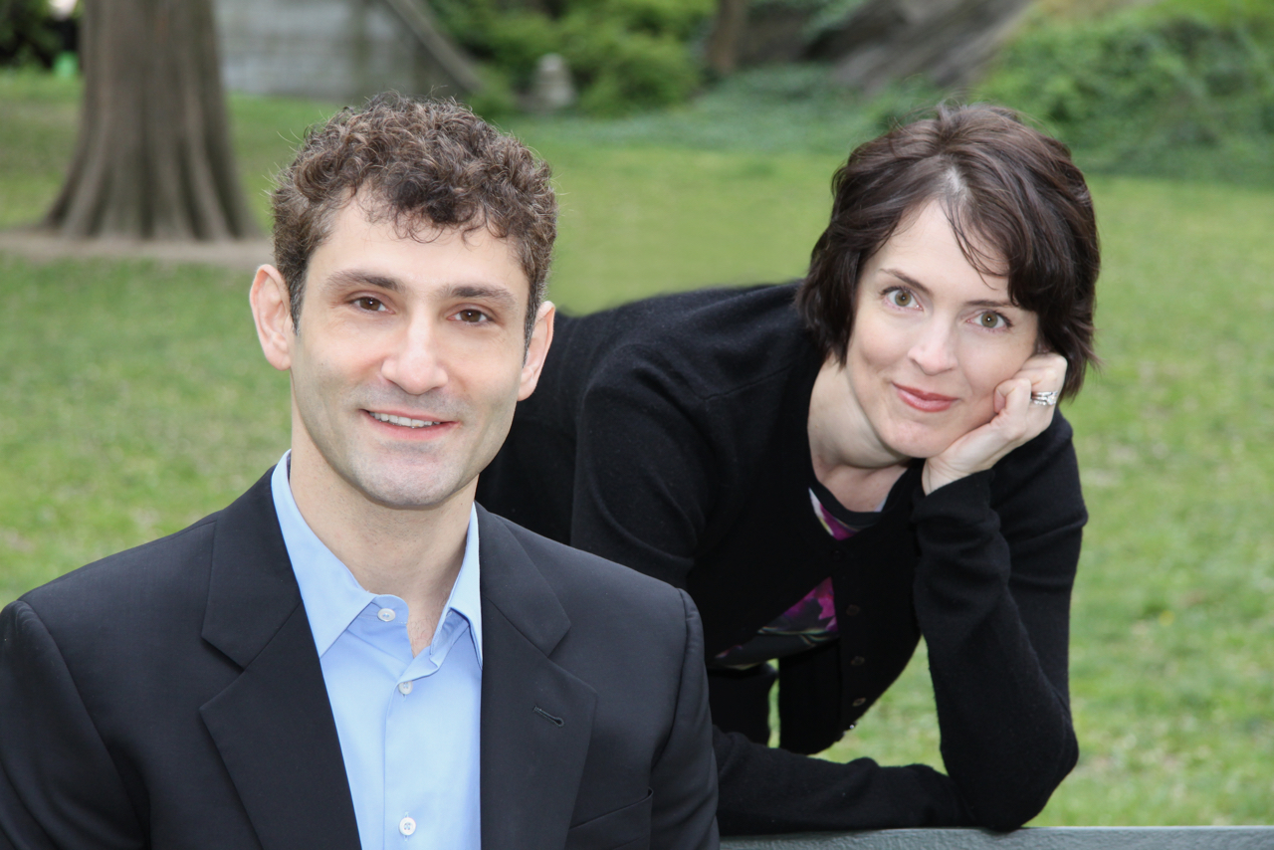
Cellist Dale Henderson and harpist Elizabeth Remy Johnson make up the Parsa Duo

Harp-cello concert at First Parish on Aug. 4

Cellist Dale Henderson and harpist Elisabeth Remy Johnson will play a concert of music by Boccherini, Stravinsky, Ravel, Prokofiev, Faure and Astor Piazzolla in the sanctuary at First Parish Duxbury on Friday, August 4, at 7 p.m.
Henderson and Remy Johnson are Massachusetts natives who trained together in Boston in the 1980s and ‘90s, studying with some of the area’s leading musicians, including Yo-Yo Ma and Benjamin Zander. Remy Johnson, a graduate of Harvard University, is the principal harpist of the Atlanta Symphony Orchestra. Henderson, a graduate of New England Conservatory, is based in New York City and is the founder of the Bach in the Subways program. The pair formed the Parsa Duo in 2015, dedicated to cultivating the joy, inspiration and high quality of music making that were so integral to their student years together.
Their most recent concert was in Rio de Janeiro in May, and they will also perform on Cape Cod and in Washington State this summer. Tickets for the concert are $20 apiece and will be available at the door.

